Algebra Tutor

Tutor Storyboard

Mujeeb Adelekan

madelekan@mail.stmarytx.edu

StMU

CS6345 eLearning and Gamification

09/30/2021

**Background and Overview**

Algebra marks a turning point in math education. It is the gatekeeper between elementary math concepts and higher-level math. Yet, despite the myriad of math tutors throughout the years, there doesn’t seem to be enough electronic games that focus on algebra.

There are many resources that assist students in algebra, including Khan Academy and Brilliant. However, Khan Academy is extremely formal and academic, giving off a dry atmosphere. Brilliant offers more involved instruction but is pricey compared to alternative means of self-instruction, like buying a textbook.

There are many math YouTube Channels that cover algebra, but, like Khan Academy, is very cut and dry in content. A YouTube Channel that teaches math through visual means in 3Blue1Brown, but his content focuses on higher-level math.

When it comes to gaming, elementary and middle school math gets a lot of attention, but algebra seems to be a missing piece outside of a few exceptions (i.e., Math Blaster Algebra). My tutor, Algebra Tutor, is designed to help fill the gap.

In designing Algebra Tutor, I was inspired by Brilliant’s instruction of algebra and ability to make the player interact with the concepts in various ways before applying the concepts with formal math notation. I intend to apply Gagne’s Nine Events of Instruction to solidify the topics covered by the tutor.

Algebra Tutor is a single user application, intended for middle or high school students struggling with algebra concepts. The topics are algebra concepts covered in an 8th or 9th grade class following Texas education standards. The prerequisites for using Algebra Tutor includes having a basic English reading ability, familiarity with basic arithmetic (addition, subtraction, multiplication, and division), and the user must be familiar with math concepts up to the 7th grade (negative numbers, fractional representation, coordinate planes, etc.)

Algebra Tutor will be developed in Unity using scripts generated in C#. The tutor is intended to run on Windows 10 Machines (Note: as of this document Windows 11 will roll out in October 2021, Algebra Tutor will presumably work on Windows 11). The game will be developed on an HP Pavilion Laptop 15z-cw100 running the Windows 10 operating system. A mouse and keyboard will be required to play the tutor.

The Algebra Tutor will consist of five lessons, each focusing on a topic with each topic building off the last. The topics are: 1) Introduction to Variables, 2) Fractions, decimals, and percentages review, 3) Constructing equations, 4) Solving Equations, and 5) Graphing lines.

Each lesson will have a Presentation, a Tutorial, and 3 questions regarding the topic. If the user does not answer at least 2 out of 3 questions correctly, the user must attempt the lesson again. Once a lesson has been completed, the user can access it at any time for a review. After finishing all five lessons, the user is given an overview of their performance and what they learned.

**Flowchart**

The following diagram is the flowchart for Algebra tutor. This describes the sequence of each screen during normal execution. The user will first see the main menu and will be given the option to play or quit. If the user has already completed lessons, the main menu will display the lessons for the user to return to at any time. The tutor consists of five lessons and each lesson has a presentation, tutorial, and questions for the user to answer. If the user fails to get the majority of questions correct, they must attempt the chapter again. At any point the user can return to the main menu by pressing the button labeled “Return to Main Menu”. **Diagram, schematic
**

**Main Menu**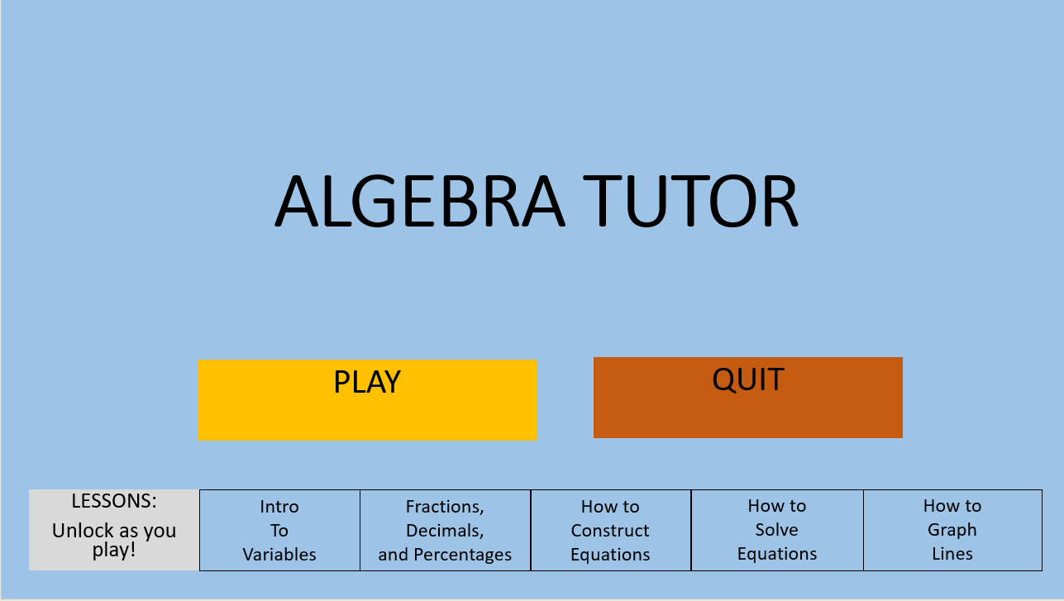

This is the first screen the user will see upon launching the program. The user can use the mouse to click the “Play” button or the “Quit” button. The buttons on the bottom, one for each lesson, will be activating when the user reaches that respective lesson in the Tutor. Once those buttons are activated, the user can select them to go to that lesson.

The user can do the following:

* Click Play
  + Goes into the Lesson 1 Presentation if first use
  + Goes into the current lesson if continuing from last use
* Click Quit
  + Close the application
* Click the lesson buttons
  + Go to the respective lesson

**Lesson 1 Presentation:**

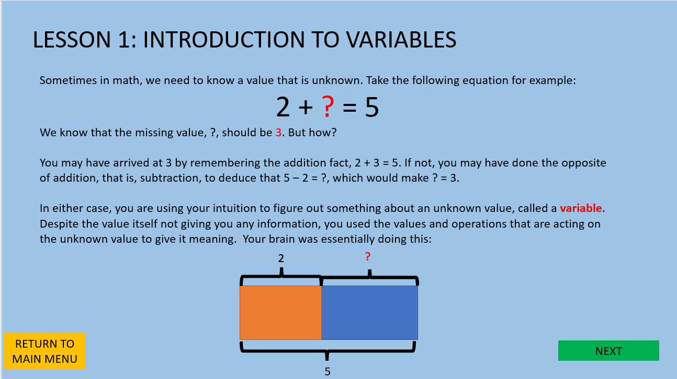

This screen will display a presentation of the content for the topic “Introduction of Variables”.

The user can click “Return to Main Menu” to be taken back to the main menu or can click “Next” to go to Lesson 1 Tutorial.

The user can do the following:

* Click “Return to Main Menu”
  + Be taken back to Main Menu
* Click “Next”
  + Be taken to Lesson 1 Tutorial

**Lesson 1 Tutorial**

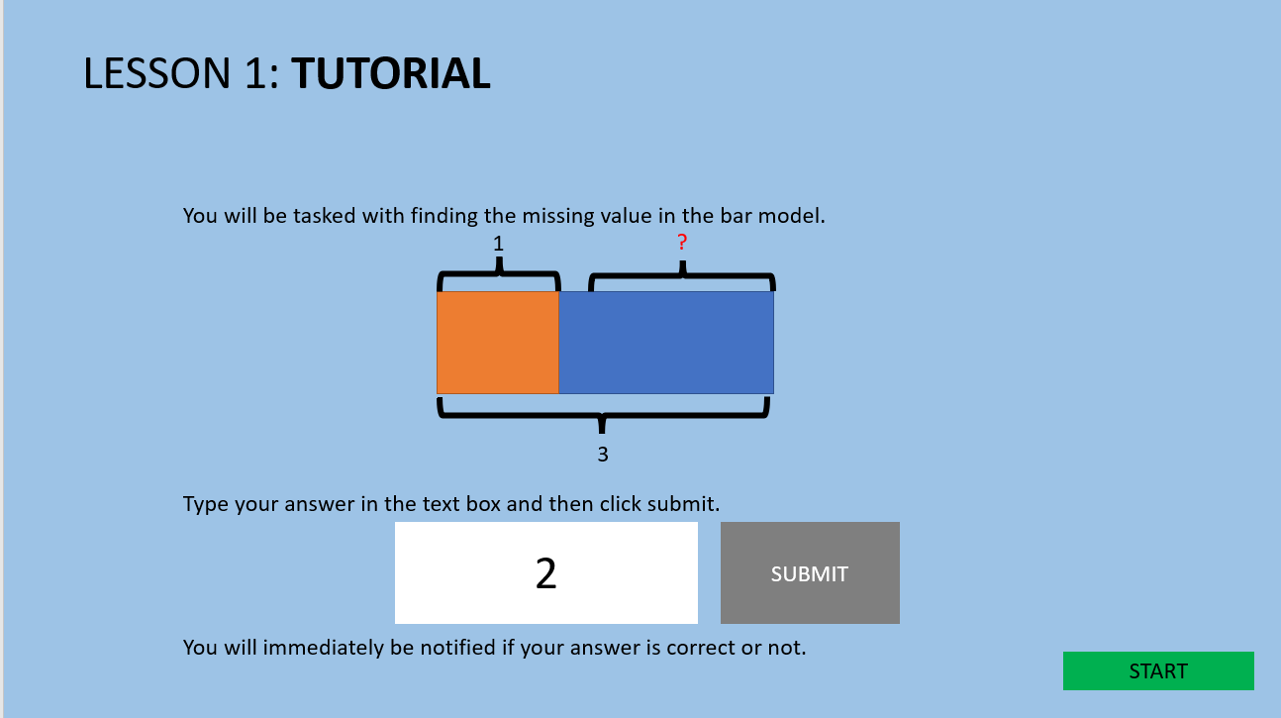

This screen will show the user how to answer questions for this lesson. After reading, the user can go into the questions by clicking “Start”.

The user can do the following:

* Click “Start”
  + Go to Lesson 1 Questions

**Lesson 1 Questions**

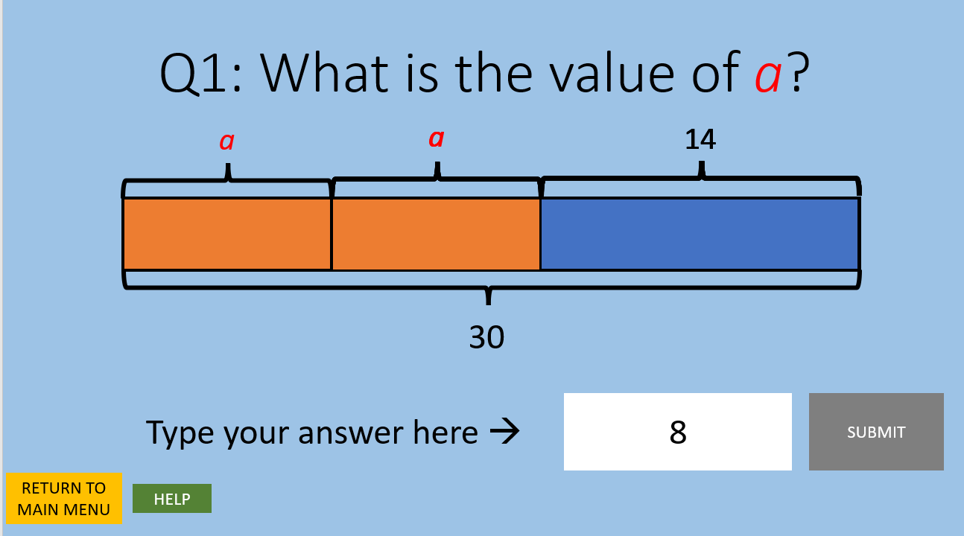

The user is tasked with answering three questions of the style above. The user must type the answer in the text box and click “Submit” to submit the answer. If correct, a pop-up will notify the user that the answer is correct. If incorrect, a pop-up will notify the user that the answer is incorrect and will give an explanation why. The user can click “Return to Main Menu” to return to the Main Menu or click “Help” to go the question’s help screen.

The user can do the following:

* Click “Return to Main Menu”
  + Go to Main Menu
* Click “Help”
  + Go to the question’s help screen
* Type in the text box
  + Show value typed
  + Enable “Submit” button
* Click “Submit”
  + If correct,
    - Show pop-up notifying user the answer is correct
  + If incorrect,
    - Show pop-up notifying user the answer is incorrect and explaining why.

**Sample Help Screen for Lesson 1**

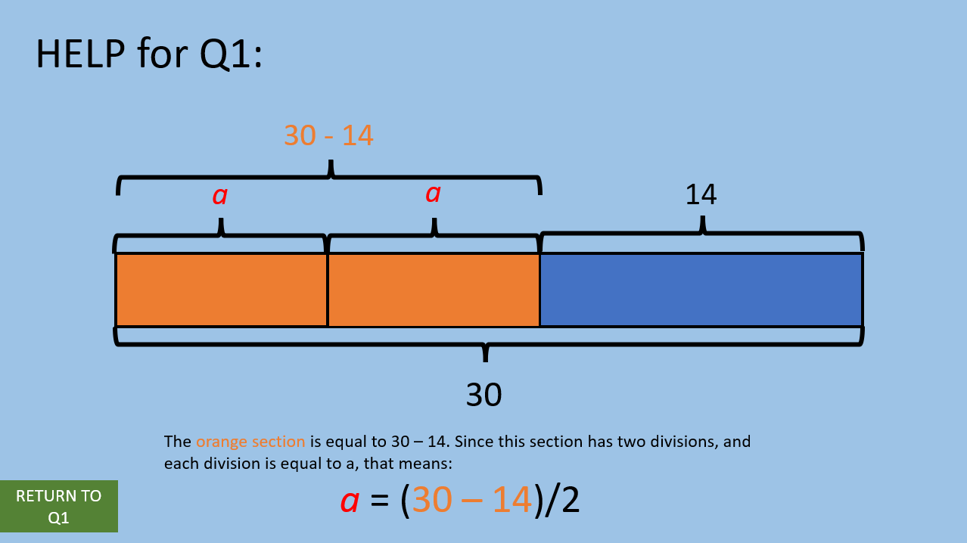

The user will see guidance for the question at hand. The user can click “Return to QX” to return to the current question, with “X” being the number of the question (e.g., Q1, Q2, etc.)

The user can do the following:

* Click “Return to QX”
  + Return user to the question screen for QX

**Lesson 2 Presentation**

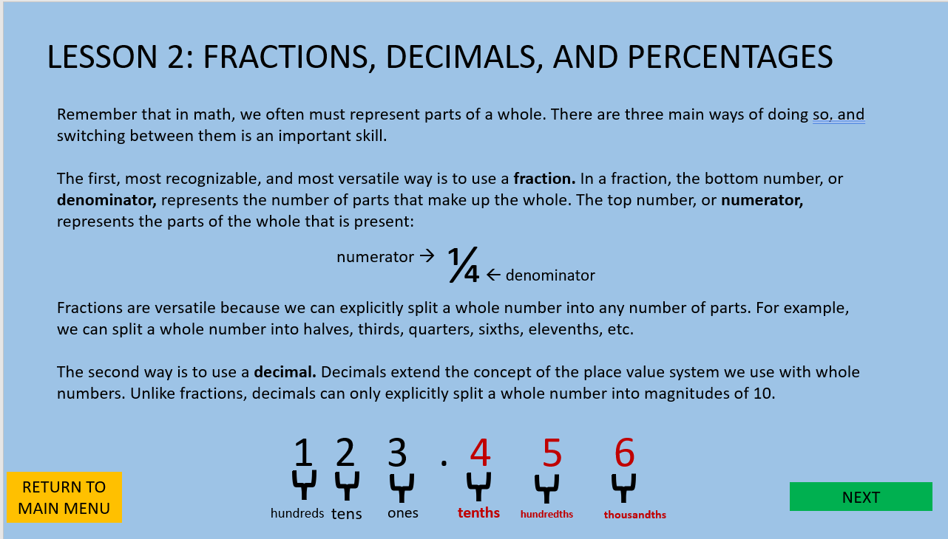

This screen will display a presentation of the content for the topic “Fractions, Decimals, and Percentages”. The user can click “Return to Main Menu” to be taken back to the main menu or can click “Next” to go to Lesson 2 Tutorial.

The user can do the following:

* Click “Return to Main Menu”
  + Be taken back to Main Menu
* Click “Next”
  + Be taken to Lesson 2 Tutorial

**Lesson 2 Tutorial**

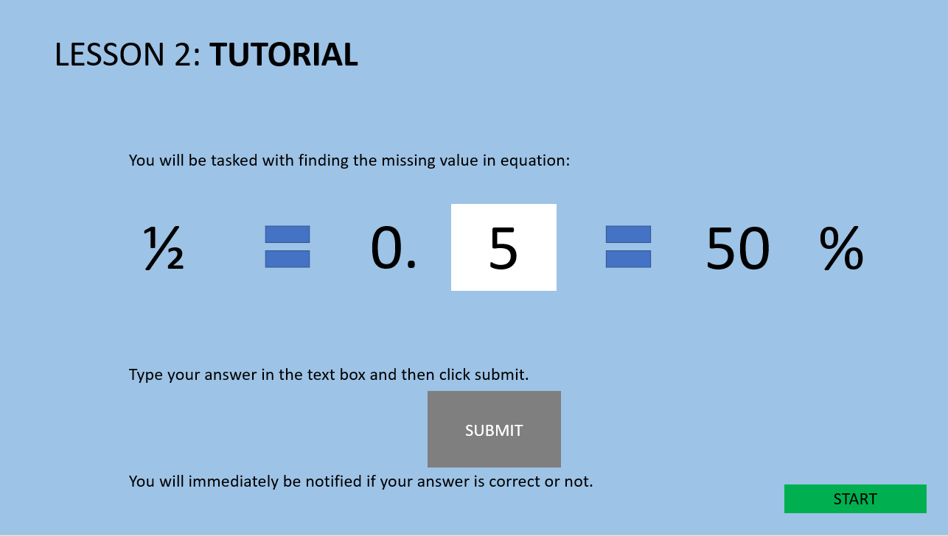

This screen will show the user how to answer questions for this lesson. After reading, the user can go into the questions by clicking “Start”.

The user can do the following:

* Click “Start”
  + Go to Lesson 2 Questions

**Lesson 2 Questions**

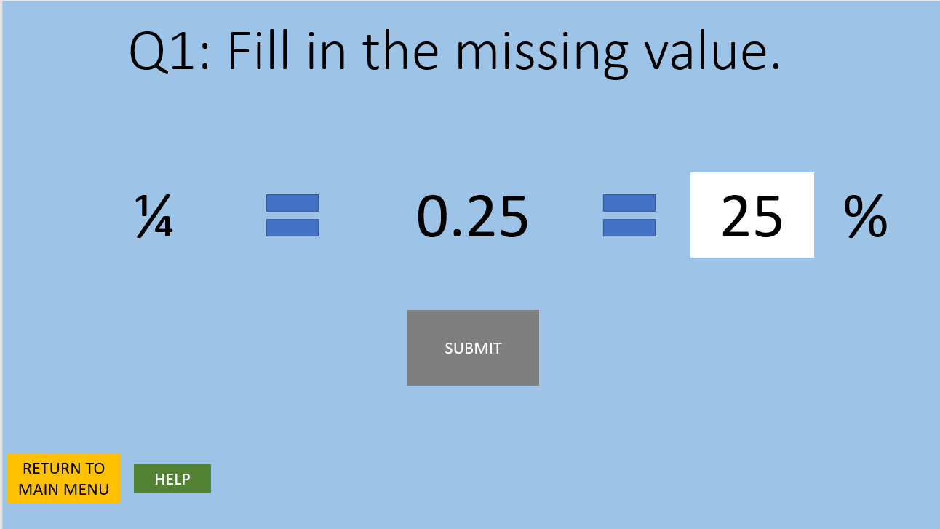

The user is tasked with answering three questions of the style above. The user must type the answer in the text box and click “Submit” to submit the answer. If correct, a pop-up will notify the user that the answer is correct. If incorrect, a pop-up will notify the user that the answer is incorrect and will give an explanation why. The user can click “Return to Main Menu” to return to the Main Menu or click “Help” to go the question’s help screen.

The user can do the following:

* Click “Return to Main Menu”
  + Go to Main Menu
* Click “Help”
  + Go to the question’s help screen
* Type in the text box
  + Show value typed
  + Enable “Submit” button
* Click “Submit”
  + If correct,
    - Show pop-up notifying user the answer is correct
  + If incorrect,
    - Show pop-up notifying user the answer is incorrect and explaining why.

**Lesson 3 Presentation**

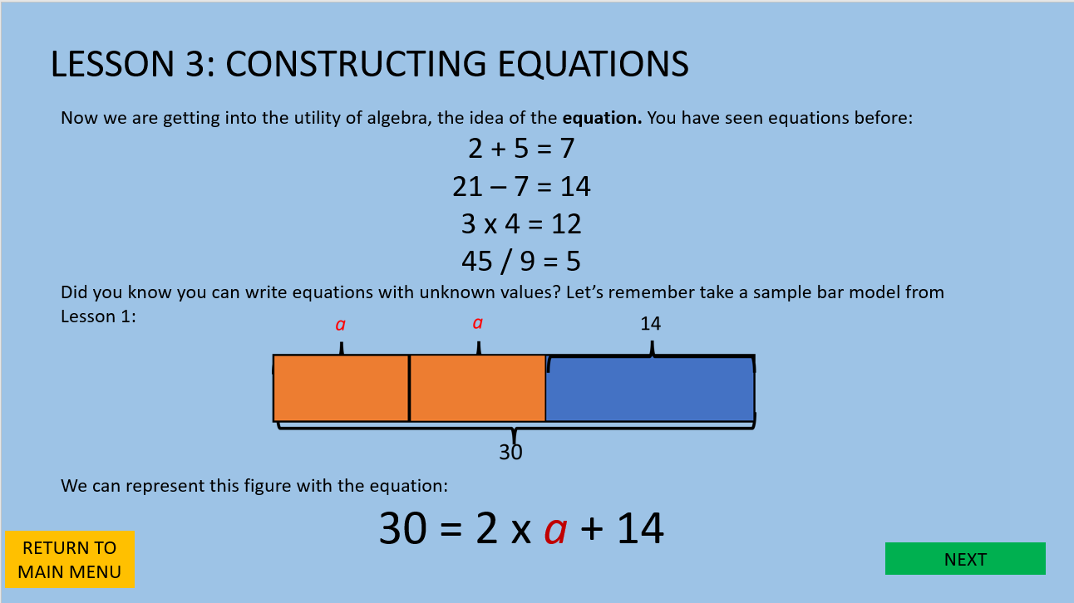

This screen will display a presentation of the content for the topic “Constructing Equations”. The user can click “Return to Main Menu” to be taken back to the main menu or can click “Next” to go to Lesson 3 Tutorial.

The user can do the following:

* Click “Return to Main Menu”
  + Be taken back to Main Menu
* Click “Next”
  + Be taken to Lesson 3 Tutorial

**Lesson 3 Tutorial**

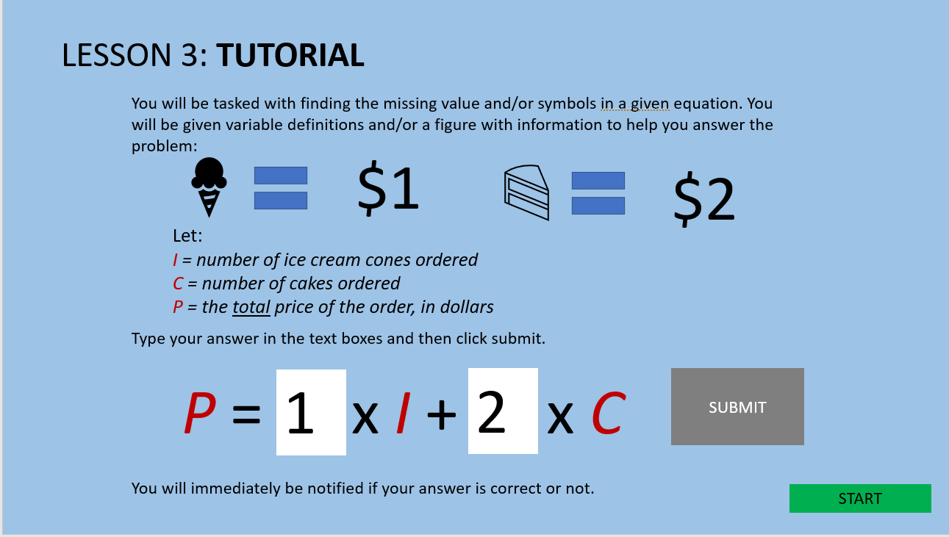

This screen will show the user how to answer questions for this lesson. After reading, the user can go into the questions by clicking “Start”.

The user can do the following:

* Click “Start”
  + Go to Lesson 3 Questions

**Lesson 3 Questions**

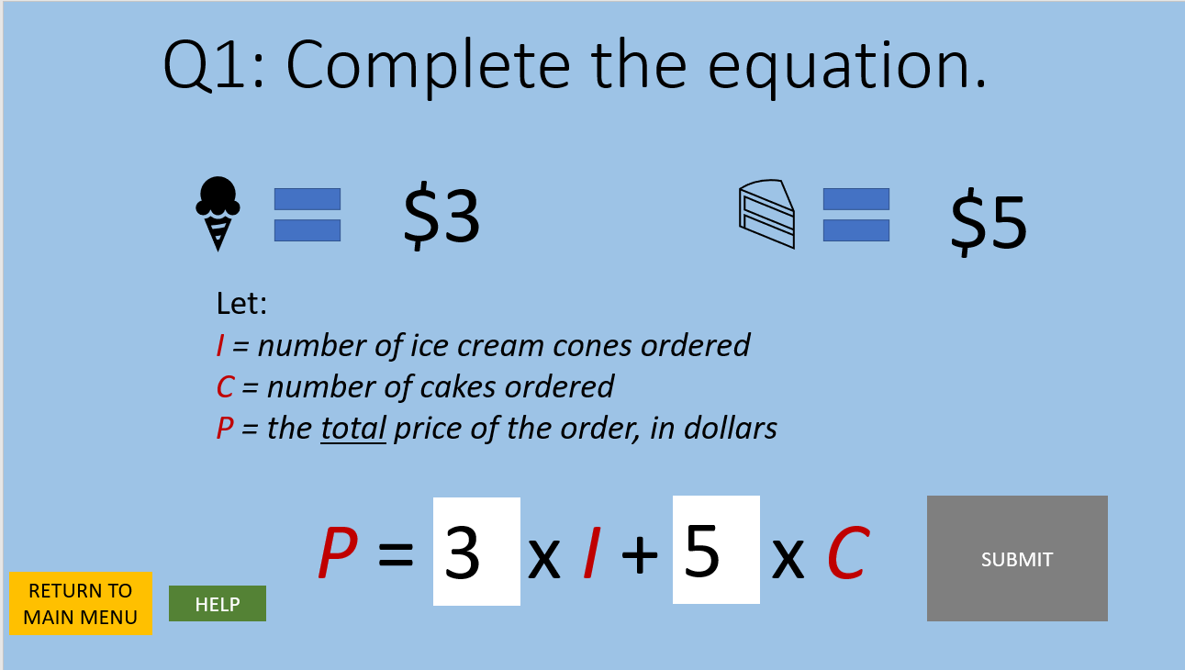

The user is tasked with answering three questions of the style above. The user must type the answer in the text box and click “Submit” to submit the answer. If correct, a pop-up will notify the user that the answer is correct. If incorrect, a pop-up will notify the user that the answer is incorrect and will give an explanation why. The user can click “Return to Main Menu” to return to the Main Menu or click “Help” to go the question’s help screen.

The user can do the following:

* Click “Return to Main Menu”
  + Go to Main Menu
* Click “Help”
  + Go to the question’s help screen
* Type in the text box
  + Show value typed
  + Enable “Submit” button
* Click “Submit”
  + If correct,
    - Show pop-up notifying user the answer is correct
  + If incorrect,
    - Show pop-up notifying user the answer is incorrect and explaining why.

**Lesson 4 Presentation**

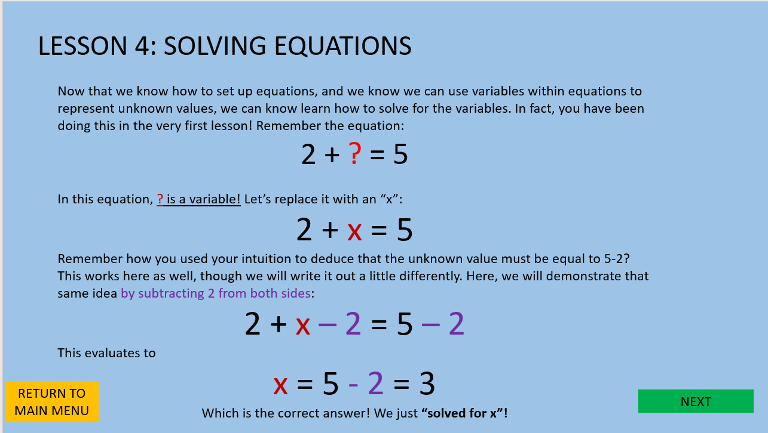

This screen will display a presentation of the content for the topic “Solving Equations”. The user can click “Return to Main Menu” to be taken back to the main menu or can click “Next” to go to Lesson 4 Tutorial.

The user can do the following:

* Click “Return to Main Menu”
  + Be taken back to Main Menu
* Click “Next”
  + Be taken to Lesson 4 Tutorial

**Lesson 4 Tutorial**

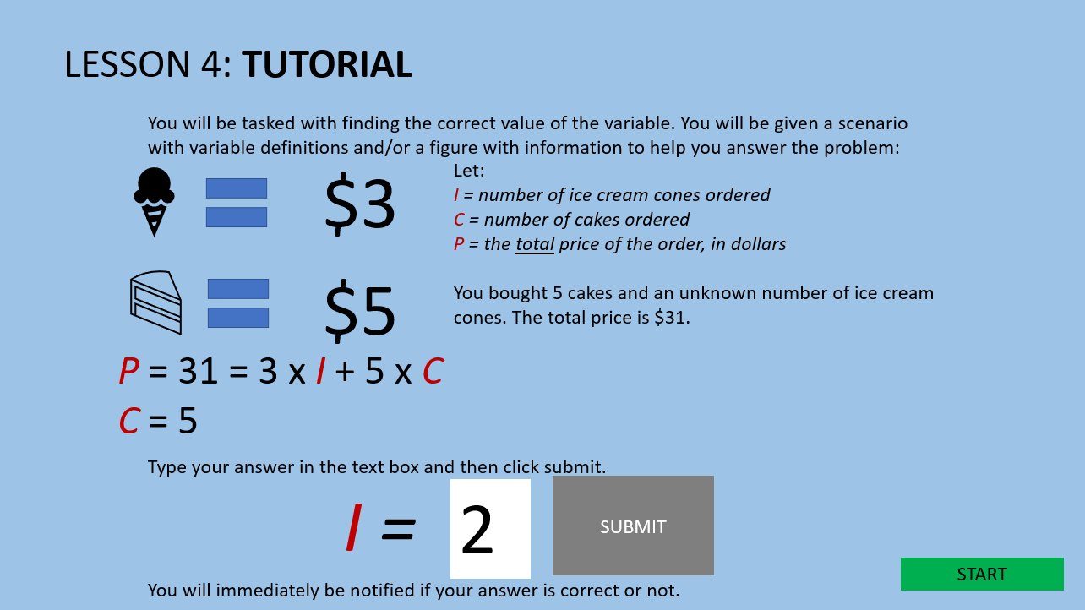

This screen will show the user how to answer questions for this lesson. After reading, the user can go into the questions by clicking “Start”.

The user can do the following:

* Click “Start”
  + Go to Lesson 4 Questions

**Lesson 4 Questions**

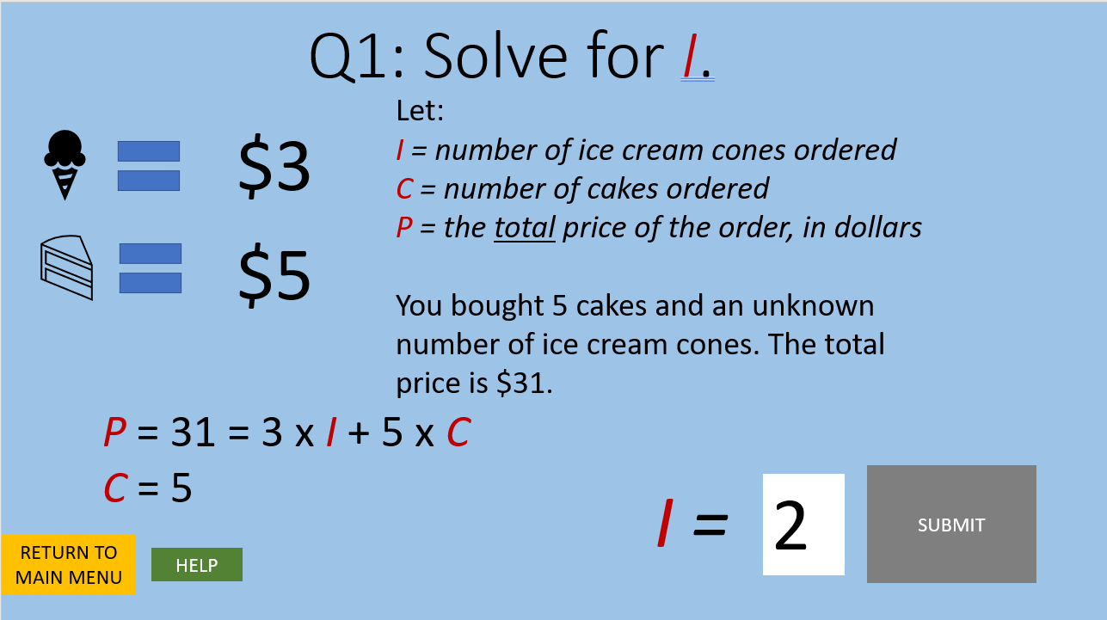

The user is tasked with answering three questions of the style above. The user must type the answer in the text box and click “Submit” to submit the answer. If correct, a pop-up will notify the user that the answer is correct. If incorrect, a pop-up will notify the user that the answer is incorrect and will give an explanation why. The user can click “Return to Main Menu” to return to the Main Menu or click “Help” to go the question’s help screen.

The user can do the following:

* Click “Return to Main Menu”
  + Go to Main Menu
* Click “Help”
  + Go to the question’s help screen
* Type in the text box
  + Show value typed
  + Enable “Submit” button
* Click “Submit”
  + If correct,
    - Show pop-up notifying user the answer is correct
  + If incorrect,
    - Show pop-up notifying user the answer is incorrect and explaining why.

**Lesson 5 Presentation**

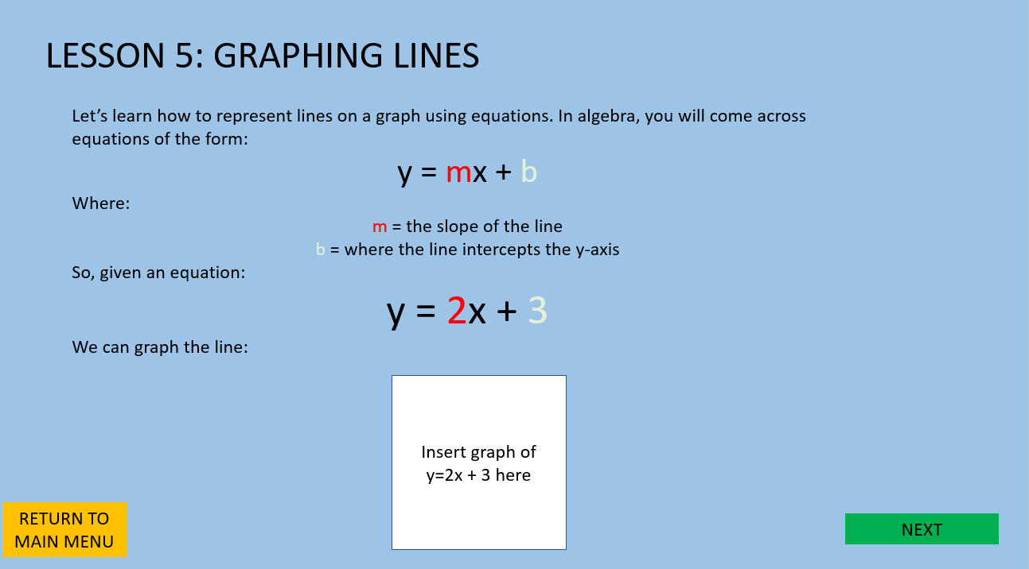

This screen will display a presentation of the content for the topic “Graphing Lines”. The user can click “Return to Main Menu” to be taken back to the main menu or can click “Next” to go to Lesson 5 Tutorial.

The user can do the following:

* Click “Return to Main Menu”
  + Be taken back to Main Menu
* Click “Next”
  + Be taken to Lesson 4 Tutorial

**Lesson 5 Tutorial**

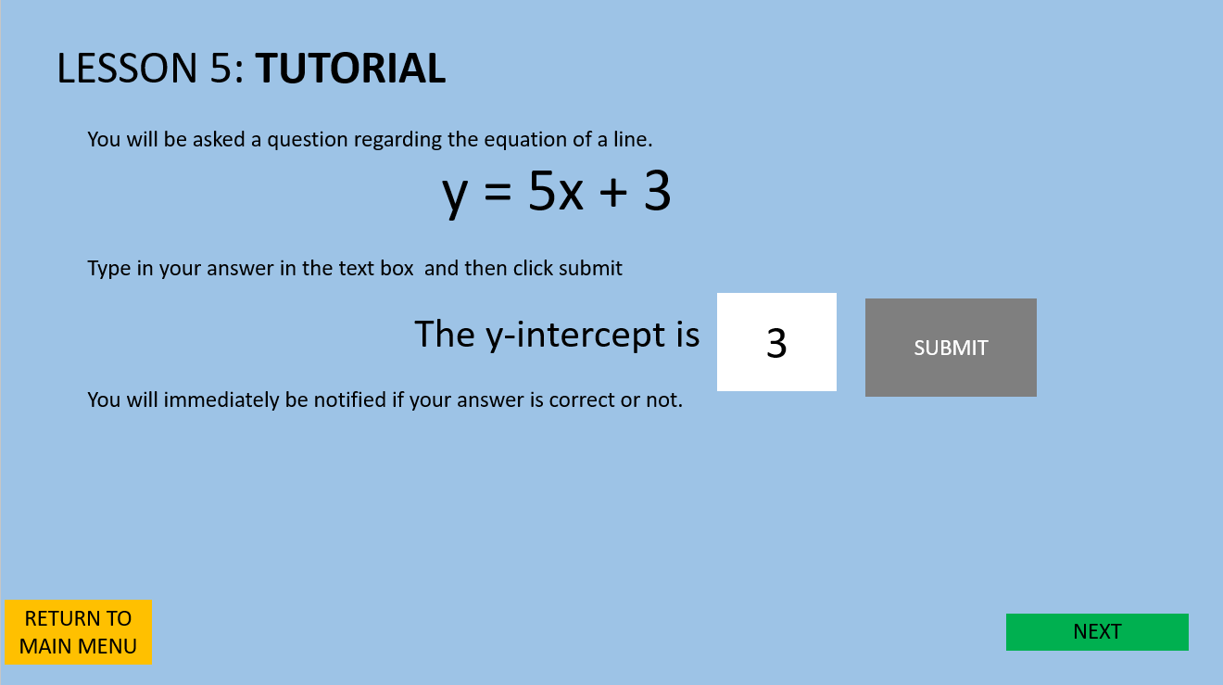

This screen will show the user how to answer questions for this lesson. After reading, the user can go into the questions by clicking “Start”.

The user can do the following:

* Click “Start”
  + Go to Lesson 5 Questions

**Lesson 5 Questions**

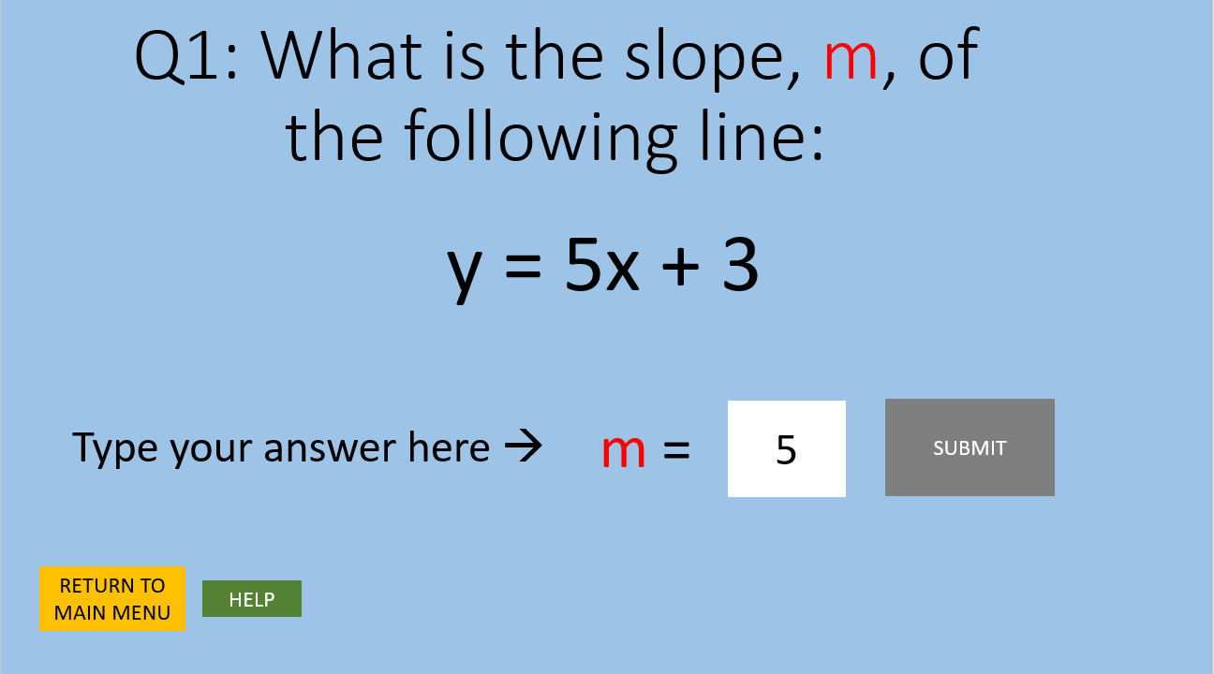

The user is tasked with answering three questions of the style above. The user must type the answer in the text box and click “Submit” to submit the answer. If correct, a pop-up will notify the user that the answer is correct. If incorrect, a pop-up will notify the user that the answer is incorrect and will give an explanation why. The user can click “Return to Main Menu” to return to the Main Menu or click “Help” to go the question’s help screen.

The user can do the following:

* Click “Return to Main Menu”
  + Go to Main Menu
* Click “Help”
  + Go to the question’s help screen
* Type in the text box
  + Show value typed
  + Enable “Submit” button
* Click “Submit”
  + If correct,
    - Show pop-up notifying user the answer is correct
  + If incorrect,
    - Show pop-up notifying user the answer is incorrect and explaining why.

**User Grade Screen**

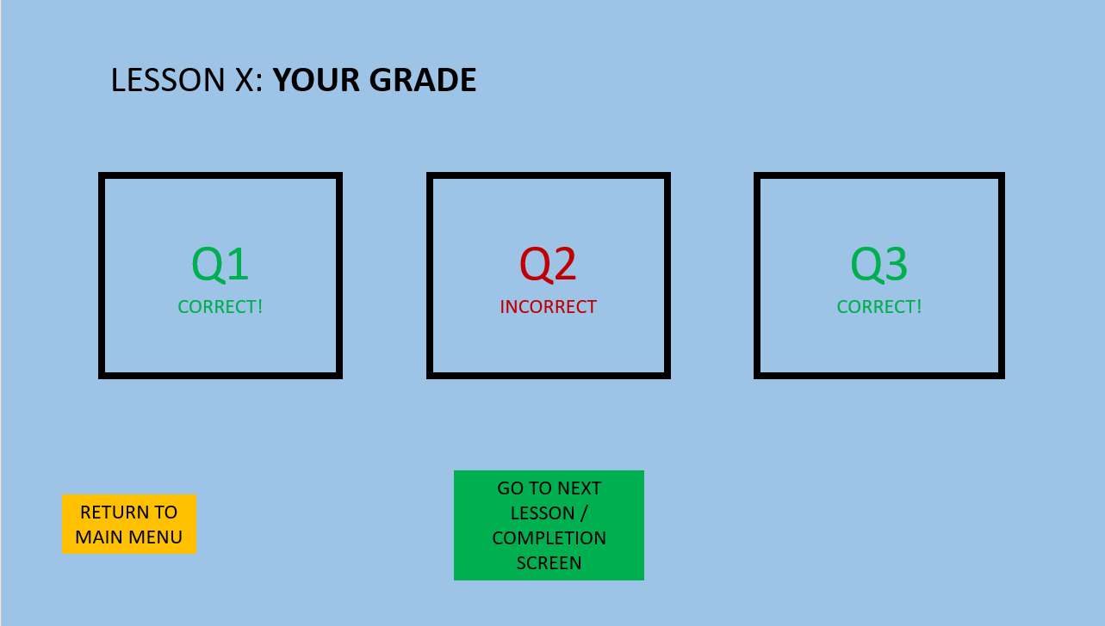

Here the user will see an overview of the questions they got correct or incorrect. The “X” will be the number of the current lesson. The user can return to the main menu by click the “Return to Main Menu” button. If the user is on lesson 5, the button will read “Go to Completion Screen” and will take the user to the Completion Screen. If the user is not on lesson 5, the button will read “Go to Next Lesson” and will take the user to the next lesson.

The user can do the following:

* Click “Return to Main Menu”
  + Go to Main Menu
* Click “Go to Next Lesson” if not on lesson 5 and “Go the Completion Screen” if on lesson 5.
  + Go to the next lesson if the user is not on lesson 5.
  + Go to Completion Screen if on Lesson 5

**Completion Screen**

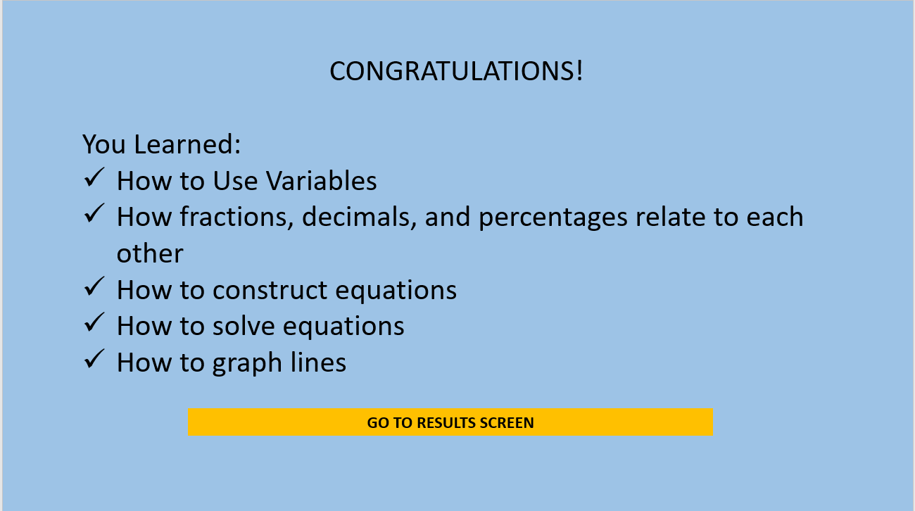

The user will see an overview of the topics they have practiced. The user can click “Go to Results Screen” to go to the Results Screen.

The user can do the following:

* Click “Go to Results Screen”
  + Go to Results Screen

**Results Screen**

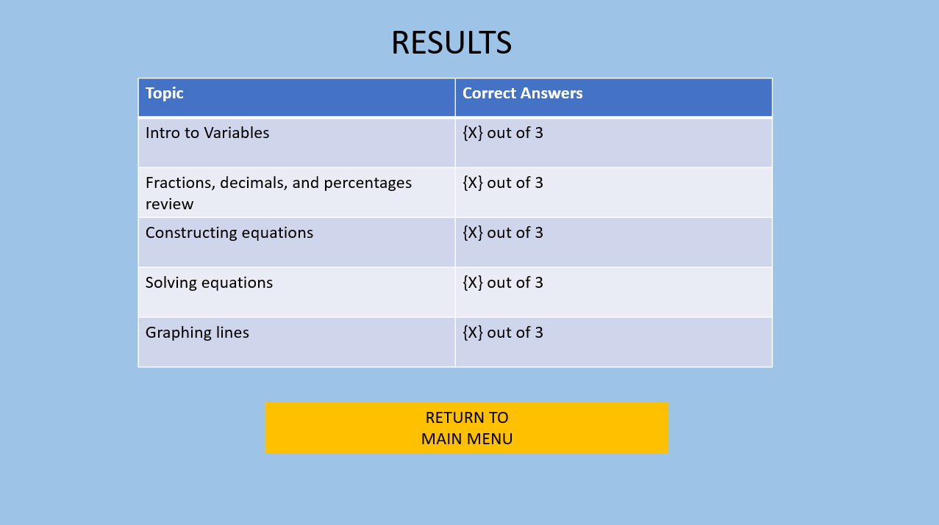

The user will see an overview of their passing grades. “X” represents the number of correct answers per each topic. The user can click “Return to Main Menu” to return to the Main Menu

The user can do the following:

* Click “Return to Main Menu”
  + Go to Main Menu